

**Much ado about something important: How do exchange rate movements affect inflation?**

Speech given by

Kristin Forbes, External MPC member, Bank of England

47th Money, Macro and Finance Research Group Annual Conference, Cardiff 11 September 2015

Thanks to Ida Hjortsoe and Tsveti Nenova for playing key roles in the analysis discussed in these comments. Further thanks to Stuart Berry, Enrico Longoni, Karen Mayhew, Gareth Ramsay,

Emma Sinclair, Martin Weale, and Carleton Webb for helpful comments. The views expressed here are my own and do not necessarily reflect those of the Bank of England or other members of the Monetary Policy Committee

Shakespeare’s famous play depicts a number of comic examples when people create “Much Ado About Nothing.” People play tricks on each other out of boredom. Much fuss is made about things that are misunderstood. People are regularly mistaken for someone else. Far too much time and energy is spent on things which do not merit it.

In contrast, movements in exchange rates are very important and merit substantial attention. They affect a country’s competitiveness – therefore influencing exports, imports, and overall GDP growth. They affect the prices of items coming from abroad – from oil and fruit to iPhone and cars – which feeds through into overall prices and how far a pay check can go. Exchange rate movements can make it much harder (or easier) to repay debt denominated in foreign currency and affect any earnings on foreign investments. Of primary importance for my discussion today, currency movements have critical implications for inflation and the appropriate stance of monetary policy.

The magnitude of recent exchange rate movements has highlighted how important these movements are for an economy and the ability of companies to compete internationally. Sterling’s effective exchange rate has appreciated 17% since its recent trough in the spring of 2013. The U.S. dollar has appreciated by about 20% over the same period, while the euro has weakened by 7%. The yen has been on a downward trend for even longer – depreciating more than 30% since June 2012. Many emerging markets have also seen their currencies weaken sharply – such as the Turkish lira which has depreciated by 30% and the Brazilian real by 42% since the start of the year (both against the dollar).

And this type of volatility in exchange rates is not unprecedented – or even unusual. Figure 1 depicts a measure of volatility in global and G7 foreign exchange markets since 2005. Even though volatility has recently picked up by this measure, it is still at about the average level since 2010 – and well below levels seen around the crisis in 2009. Volatility in exchange rates can create substantial challenges for exporters, but may simply be a fact of life to which we need to become accustomed.

Even though recent exchange rate movements are not particularly unusual, they have still generated a substantial amount of attention. Ironically, it is some of the smaller movements that have created the most “ado”. For example, when China devalued the yuan by about 2% on August 11, the global response and rhetoric was rapid. Both the IMF and U.S. Treasury quickly released formal statements, and many

Asia-Pacific currencies immediately fell against the dollar. China-sensitive commodity prices dropped sharply

– such as copper and aluminum which reached 6-year lows. The “fear index”1 recorded the largest two-day increase in its history, reaching an intra-day high that was last hit at the end of 2011 as the euro area crisis unfolded. On August 11th, the *Financial Times* described these market gyrations in an article entitled: ‘Surprise China Devaluation Marks Escalation of Currency War’. In the UK, analysts and the press quickly assumed that increased volatility and uncertainty following China’s currency adjustment would cause the

1 The VIX index, which measures 30-day implied volatility on the S&P 500.

MPC to delay raising interest rates.2 And yes, I said the yuan devaluation which prompted this uproar was about 2%, not 20%.

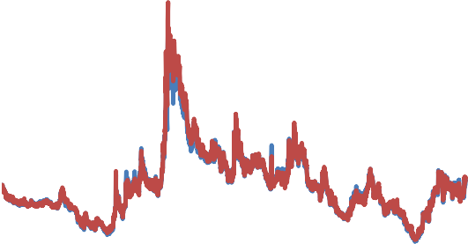

|  |  |
| --- | --- |
| **Figure 1: JP Morgan G7 and Global FX implied volatility indices**  30  25  20  15  10  5  0  2005 2007 2009 2011 2013 2015  G7 Global | Sterling’s recent appreciation has generated much less fuss, but its effect on UK inflation and monetary policy has been much more substantive. Sterling’s appreciation has contributed to a sharp fall in import prices, which has been one important factor driving inflation to around zero today (along with the sharp declines in energy and food prices). Sterling’s appreciation was mentioned eight times in the March and August 2014 Minutes of the Monetary Policy Committee (MPC), and eleven times in the August 2015 Minutes. That could be a record – but I didn’t have enough coffee to check all the historic Minutes. Whether a record or not, currency movements have  been a key factor allowing the MPC to keep interest |

rates on hold, despite the solid recovery and without worrying (yet) about inflation overshooting our 2% target. How sterling’s most recent appreciation, and any future currency movements, affect prices will be a critically important determinant of when is the appropriate time to begin raising interest rates.

Despite all of this “ado” and the important effects of currency movements, we have a surprisingly poor understanding of exactly how exchange rate movements affect inflation. Yes – there is a large academic literature (to which I will return below) and there is no shortage of analysis and debate. But our existing models and estimates have shown their substantial limitations. Some of what we have believed to be key tenets in our understanding do not hold up terribly well in UK data. My comments today will discuss three of these seeming misunderstandings. First, contrary to common belief, exchange rate movements don’t seem to consistently have larger effects on prices in sectors with a higher share of imported content. Second, exchange rates don’t seem to consistently have larger effects on prices in the most tradable and internationally-competitive sectors. Third, the effects of exchange rates on inflation – and even just on import prices – do not seem to be consistent across time. Most of what I learned in grad school on this topic no longer seems to apply.

We clearly need to improve our framework for understanding pass-through. We are missing something. This limited understanding of how exchange rate movements affect inflation is – to be candid – quite frustrating for those of us tasked to set monetary policy. This is a crucial relationship – especially for an open economy such as the UK.

2 For example, *The Guardian* reported that: “The first rise in UK interest rates could be delayed until autumn 2016, according to City expectations, as market turmoil in China raises the prospect of historically low borrowing costs staying in place for longer than expected.”

My comments today will begin by describing the standard approach to estimating pass-through. Then it will discuss three misunderstandings that present challenges to this approach. I will end by outlining a new way of thinking about how exchange rate movements affect prices, a fundamentally new approach that could explain at least some of these anomalies. These comments summarize work from a project with Ida Hjortsoe and Tsveti Nenova, who are also at the Bank of England (BoE). To be clear, these results are from an independent research project, and although we have benefited from extremely helpful discussions with some of our BoE colleagues, my comments today do not represent the official views of the Bank of England or the Monetary Policy Committee, or any formal change in BoE forecasting models.

The line of research about which I will talk today, however, suggests an intuitive new framework that could provide a critical missing piece in understanding how exchange rate movements affect inflation. The framework will undoubtedly need to be fine-tuned and improved on. But part of why I was delighted to have this chance to talk to this impressive audience of academics today was that I was hoping to stimulate some of you to think about this framework, comment on it, identify any shortcomings, and even build on it in the future.

More specifically, we propose that when analysing how exchange rate movements affect inflation, it is crucially important to consider a factor that has previously been largely ignored in this literature – what drives the initial exchange rate movement. For comparison, when we analyse how a change in oil prices affects the UK, we understand that the effects depend critically on whether the change in oil prices was driven by changes in the global supply or demand for oil. In contrast, when thinking about how changes in currency prices affect the UK, people generally do not focus on why the currency price initially changed. But whether a country’s currency is strengthening because of changes in domestic demand, global demand, domestic monetary policy, global supply shocks (including oil), or domestic productivity – could be critically important in determining how the currency movement affects inflation and the economy.3 Not surprisingly, companies will adjust their prices and margins in different ways based on why the exchange rate is moving.

Analysis that does not consider the source of the exchange rate movement may provide a blurred picture and make it difficult to forecast its effects. For example, we show that when exchange rate movements result primarily from changes in domestic and global demand, they are associated with very different inflation dynamics than other types of shocks – undoubtedly due to the support to company sales from stronger demand. Incorporating these types of considerations goes some way to explaining why exchange rate movements have been associated with such different effects on prices at different points over the last decade – an issue of much frustration for those of us attempting to forecast inflation.

3 Bussiere, Lopez and Tille (2015) recently raised a related point that exchange rate appreciations driven by domestic productivity shocks would have different effects on growth than movements driven by surges in capital inflows. Shambaugh (2008) is the only example of an academic paper that we have found which considers how the source of the exchange rate shock could affect

pass-through. Kirby and Meaning (2015) discuss how different shocks affect the degree of exchange rate pass-through for the UK using NIESR’s global structural model.

For example, sterling’s depreciation during the crisis increased import prices and inflation by more than was generally expected. We show that this can at least partly be explained by the reasons behind the depreciation – that it reflected an unusually large decline in domestic and global supply. Sterling’s recent appreciation has been driven by a very different set of factors, which could explain why it has had less drag on import prices than was generally expected. If this trend continues, it would have important implications for how recent movements in sterling affect future inflation, and therefore monetary policy.

Although this new approach could help us understand why it has been so hard to estimate how exchange rate movements affect inflation – and especially how that relationship can change so quickly over time in a country such as the UK – it is not meant to be exhaustive and does not capture all the subtleties of how exchange rate movements affect inflation. For example, there are many structural differences across countries that are important in explaining different effects of exchange rate movements – such as the currency composition of invoicing, the share of debt in foreign currency, and the monetary policy framework.4 The fact that the exchange rate sometimes moves in different directions with respect to different currencies might also play a role.

Nonetheless, a greater consideration of why an exchange rate moves could improve our understanding of its effects and our ability to forecast the impact on inflation in the future. Most important, a clearer understanding might create “less ado” about the effects of exchange rate movements and how monetary policy should respond.

# What do we know?: current evidence on how exchange rate movements affect inflation

Economists use the term “pass-through” to capture how changes in the exchange rate “pass-through” to import prices, and then to the broader price level and corresponding rate of inflation. Although the concept is simple, many factors can influence this relationship. This makes predicting exactly how exchange rate movements affect prices less straightforward. Figure 2 gives an idea of the various mechanisms that are in play when sterling moves against the euro. This is replicated from a former speech (Forbes, 2014) in which I discuss the past literature and evidence on pass-through. 5 I will not repeat this summary of the literature here – especially as many of you in the audience are undoubtedly familiar with it – but instead refer you to the speech if you are interested.

4 See Gopinath (2015) for the role of currency invoicing and Stulz (2005) for the role of monetary policy expectations. See also Fleer,

Rudolf and Zurlinden (2015), who consider a related angle that sectors with a high price-change dispersion tend to have larger pass-through than sectors with low price dispersion.

5 See Burnstein and Gopinath (2013) for a recent overview of the academic literature on pass-through and Mishkin (2008) for a discussion of exchange-rate pass-through and the implications for monetary policy.

# Figure 2: Exchange rate pass-through after movements in the sterling/euro exchange rate

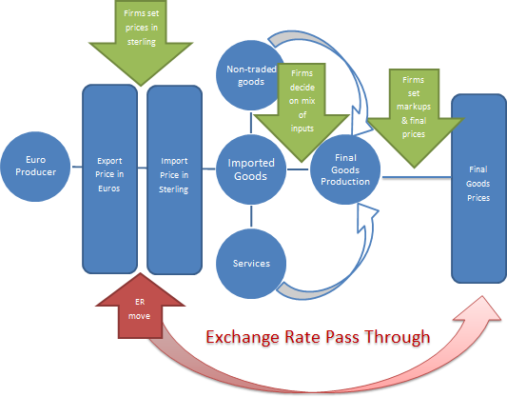

For those of you who are not familiar with this literature, however, let me just quickly highlight a couple of key points that are critical to the discussion below but are often misunderstood. When discussing how exchange rate movements affect prices, it is important to differentiate between the two phases of pass-through. In the first phase, changes in the exchange rate affect import prices. This effect is believed to occur fairly quickly and be largely complete within a year. In the second phase, these changes in import prices feed through into the overall price level and inflation. This second phase is believed to be quite slow – with many estimates suggesting that it can be roughly 3 to 5 years before most of the adjustment is made (and even longer for the full effect). This second stage is also more difficult to estimate, as it depends on a broad range of

hard-to-measure variables, including inflation expectations and the credibility of monetary policy.

Understanding how exchange rate movements first affect import prices and then overall inflation may sound like a tedious technical issue of interest only to academics and central bankers. But the effects are substantive enough that they should merit consideration by anyone trying to figure out where prices are going and what is next for interest rates.

Using very rough rules of thumb, the BoE has traditionally estimated that the pass-through from exchange rate movements to UK import prices is roughly 60% to 90%, and the import intensity of the consumer price index (CPI) is about 30%.6 This generates an overall pass-through coefficient of around 20% to 30%.7 In

6 These numbers have changed over time due to a variety of factors – as will be discussed below – so this example is only meant as a rough guide to the magnitude of the effects.

7 The 20% is about 60% x 30%. The 30% is about 90% x 30%. These are all rounded to highlight that they are very rough estimates. These are multiplied by the size of the exchange rate movement to estimate the final pass-through to prices.

other words, the 17% appreciation of sterling that has occurred since the spring of 2013 would reduce the level of the consumer price index by about 3 to 5%. Even if this is spread across several years, this effect on prices and inflation is meaningful. And in a recent speech, I raised the possibility that exchange rate

pass-through may be occurring faster today than in the past, accelerating the immediate impact on inflation.8

But the magnitude of these estimates seems large relative to the more modest falls in import prices recently. Especially, after taking into account BoE analysis suggesting that other factors are currently also playing an important role in dragging down inflation. Recent declines in energy and food prices are estimated to be dragging down inflation by around 1¼ percentage points compared to the pre-crisis average contribution.9 Low inflation in key trading partners, and any remaining slack in the economy, may also be restraining wages, domestic costs, and prices. Is there other evidence on the role that exchange rate movements play in driving inflation dynamics?

Micro-level data provides a useful check on the impact of exchange rate movements on prices, as well as of its importance relative to other factors influencing inflation. More specifically, we use data on the prices of each of the 85 separate goods and services that comprise the UK headline CPI index from 1996 through September 2008.10 Then we estimate a series of component level regressions to evaluate how closely the prices of each of these 85 sectors moves with changes in four variables: sterling, oil prices, foreign export prices, and the output gap.11

Appendix A lists the 10 goods and services that are most correlated with each of these four variables (along with their corresponding estimated correlations).12 The results are largely intuitive. For example, sectors whose prices move most closely with oil prices are “liquid fuels” and “fuels and lubricants” – with low correlations between oil prices and prices in other sectors. Sectors whose prices move most closely with sterling are often related to food and energy (such as air transportation, vegetables, gas, fuels, tobacco, and food products). These are sectors where prices are largely set in international markets and it is therefore not surprising they are highly sensitive to exchange rate movements. Most sectors tend to have very low correlations with the output gap, supporting evidence of a “flat” Phillips curve and low estimated correlations between the output gap and inflation.13

8 See Forbes (2015a). The Federal Reserve Board assumes a substantially faster rate of pass-through to inflation, as shown in Fisher (2015).

9 This is consistent with the Governor’s recent letter to the Chancellor of the Exchequer dated August 6 2015, in which he points out that the recent drops in energy and food prices explain about 1½ percentage point of the deviation of inflation from target, when combined

with the downward pressure from sterling’s appreciation.

10 We end the analysis in 2008 in order to avoid confusing the effects of the exchange rate depreciation in 2007/8 with the VAT changes in the UK in the following years, which are likely to have affected the CPI components to different degrees.

11 The estimation method for these 85 component-level regressions is basically a New Keynesian Phillips curve model with explanatory

variables for expected and lagged inflation, changes in the sterling exchange rate index (ERI), oil prices in US dollars, foreign export prices in foreign currency, and the UK output gap. We follow the literature and use lags of these variables as instruments to correct for the endogeneity arising from the use of actual future inflation as a proxy for expected inflation. See Forbes (2015b), Table 2 and related text, for further detail.

12 The ranking is based on the test statistic of the regression coefficient of each good/service to the respective explanatory variable. The

goods most correlated with sterling are those with the most negative t-stat from the GMM regression, whereas the goods most correlated with oil, foreign export prices and the output gap are those with the highest positive t-stat associated with the coefficient on each of those variables.

13 See Forbes (2015b).

Next, we use these estimates from Appendix A of the sectors most sensitive to changes in exchange rates, oil prices, foreign export prices, and the output gap to calculate how movements in each of these more sensitive goods and services affect overall inflation. More specifically, each graph in Figure 3 shows CPI inflation since 1998 in the blue lines. The red bars in each graph show how much of this inflation can be explained by price changes in the “basket” of the 10 goods or services identified as being most sensitive to movements in either sterling (part a), oil prices (part b), foreign export prices (part c), or the output gap (part d).14 In other words, Figure 3a shows how much of headline inflation is explained by the basket of 10 goods and services most sensitive to sterling’s moves. It shows the actual contribution to overall inflation from these sectors (rather than estimates of how sterling or other factors influenced UK inflation through these sectors). The goal is to see whether sectors particularly sensitive to certain price movements and variables explain a disproportionate share of recent movements in UK inflation.

A quick look at Figure 3 suggests that movements in just the 10 sectors more sensitive to sterling’s movements explain a significant share of movements in overall inflation. In fact, this sterling-sensitive basket (and by extension probably movements in sterling) explains more of the CPI than the corresponding baskets and movements for oil prices, foreign export prices, and the output gap. More specifically, the

sterling-sensitive basket has on average accounted for 29% of overall CPI inflation over the 1998-2015q1 period, the oil-sensitive basket for 22%, the foreign export price-sensitive one for 10%, and the output

gap-sensitive basket has averaged around 0%. And the correlation betweenthe sterling-sensitive basket’s inflation rate and quarterly CPI inflation was 0.85 during the same period, that of the oil-sensitive basket was 0.66, for the foreign export price-sensitive basket it was 0.63, and that for the output gap-sensitive basket was 0.79.

This simple analysis suggests that if one wants to understand movements in headline inflation, it is critically important to consider movements in the exchange rate, and in turn, how exchange rate movements affect different prices throughout the economy. Unfortunately, this is where things begin to get complicated. In the following, I will point out three common misunderstandings on exchange rate pass-through, and propose a framework which could potentially explain why these arise.

14 The same good can appear in more than one basket. This reflects the fact that, for example, goods that are traded in international markets may be sensitive to both movements in the exchange rate and foreign export prices.

# Figure 3: Annual CPI inflation and contributions from the components most correlated* with sterling, oil, foreign export prices and the UK output gap

*a) Sterling b) Oil price*

5 5

10 components most correlated with sterling CPI

10 components most correlated with oil

CPI

4 4

3 3

2 2

1 1

0 0

-1

1998 2000 2003 2006 2008 2011 2014

-1

1998 2000 2003 2006 2008 2011 2014

*c) World export prices d) UK output gap*

5 5

10 components most correlated with world export prices

CPI

10 components most correlated with UK output gap

CPI

4 4

3 3

2 2

1 1

0 0

-1

1998 2000 2003 2006 2008 2011 2014

-1

1998 2000 2003 2006 2008 2011 2014

* The goods most correlated with each of the factors are those with the highest t-stat from a Phillips curve equation, which includes all four variables above along with the inflation lag and lead for each component. For sterling we use the most negative t-stat, as we would expect prices to fall in response to an exchange rate appreciation. See Forbes (2015b) for further detail of the estimation method.

# Misunderstanding 1: pass-through is greater in sectors with a greater import content

One of the standard assumptions used to estimate pass-through is that countries and sectors that have a higher share of imported goods or imported content should exhibit a greater sensitivity of prices to exchange rate movements. Granted, there are other factors that could mitigate this relationship – such as the degree of competition (discussed below) or the currency in which prices are calculated. But at a broad level, one would expect to see a pattern that sectors with a greater share of imported content tend to be more sensitive to changes in the exchange rate. To take an example often used in economic textbooks, one might expect that prices in the sector “hairdressing” (a sector that is clearly labour-intensive, with a low import content, and hard to trade across borders) would not see prices that fluctuate substantially based on exchange rate movements. On the other hand, one might expect that prices in a sector such as fruit – which is largely imported in the UK – would be more sensitive to exchange rate movements.

To see if this intuitive relationship holds, we use the correlations between prices in each of the 85 sectors discussed above and sterling’s movements to estimate a “sterling coefficient” that captures how sensitive prices in each sector are to sterling’s movements.15 Figure 4 shows the resulting sterling coefficients (in yellow) and the import-intensity of each sector in blue. The sectors are shown starting on the left with those with lower import intensities and moving to the right as import intensities increase. One would expect to see a general pattern in which the sterling sensitivity as proxied by the sterling coefficients (the yellow lines) tend to increase gradually as you move from left to right—roughly following the pattern for the blue lines capturing import intensity by sector. (To simplify readability, sterling sensitivity is expressed so that a higher number means a higher price fall after an exchange rate appreciation.)

But the yellow lines show no such pattern – even if you squint or look with one eye. There is no evidence that prices in sectors with a higher import intensity are more correlated with sterling’s movements.16 Sensitivity to sterling appears to occur randomly when sectors are ranked by import intensities. In fact, the correlation of sterling sensitivity and import intensity by sector is even negative at ‒ 0.08! This is not only close to zero, but the opposite sign of what one would expect.17

15 The estimation method for these component-level regressions is described in footnote 11.

16 This analysis uses the publicly available direct import intensities published [here](http://www.google.co.uk/url?sa=t&rct=j&q&esrc=s&frm=1&source=web&cd=1&ved=0CCIQFjAAahUKEwi9j-GM6OfHAhVClYAKHf68CKc&url=http%3A%2F%2Fwww.ons.gov.uk%2Fons%2Fabout-ons%2Fbusiness-transparency%2Ffreedom-of-information%2Fwhat-can-i-request%2Fpublished-ad-hoc-data%2Fecon%2Fmay-2015%2Festimated-import-intensity-of-household-consumption-by-coicop--2010.xls&usg=AFQjCNHzV_ztptKlAeV-KxjRdRE75QloAw) by the ONS. The results are unchanged if we adjust

the import intensities to account for the imported intermediate goods used in the production of the final consumption goods and services in the CPI basket (which is based on confidential data and therefore not reported here).

17 The estimated sterling coefficients remain little changed if we exclude the large 1996/7 sterling appreciation – the only large sterling

move during the estimation period – from the sample. At this level of disaggregation, however, it may be the case that the lack of sterling sensitivity of some import intensive goods partly reflects the fact that they are only sensitive to a specific sterling bilateral exchange rate. Some sectors might also be very slow in adjusting domestic prices in response to a change in the imported prices. Our framework does not examine these different dynamics.

# Figure 4: Import intensities of 85 CPI components and their price sensitivity to changes in sterling

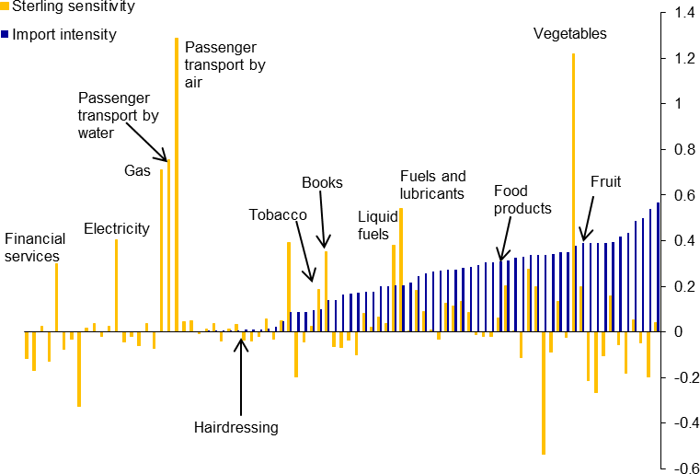

|  |  |
| --- | --- |
| As an additional check on this puzzling relationship, we examine the correlations between sterling sensitivities and import content for broader groups of 29 goods and services – hoping that the expected pattern might at least appear in this more aggregated sectoral data.18 A summary of this analysis is shown in Figure 5, which graphs each sector by import intensity on the y-axis and sterling sensitivity on the x-axis. The negative slope is again the opposite of what we would expect. Goods with higher import content appear to be less sensitive – instead of more  – to sterling’s movements (although the relationship has little explanatory power with an R2 of close to zero).  The puzzle deepens. | **Figure 5: Import intensity (x-axis) and sterling sensitivity (y-axis) of 29 broader CPI components**    *We would expect a positive relationship. The picture is unchanged if we exclude fruit & vegetables as well as energy. |

18 The group of goods and services chosen is those publically available in the Eurostat PPP database.

# Misunderstanding 2: pass-through is greater in sectors that are more tradable and internationally competitive

One possible explanation for why exchange rate sensitivity appears to have little relationship to import intensity across sectors is that other characteristics of the sector are more important – such as its tradability or degree of international competition. More specifically, consider what happens when sterling appreciates and causes import prices to fall. UK firms producing goods sold in the UK, but prone to international competition, might have to reduce their prices in line with the price reductions of similar foreign goods in order to avoid losing market share. This implies that if goods are tradable and/or compete with international goods – despite being produced and sold in the UK and having minimal import content – their price could still be sensitive to changes in the exchange rate.

A good example of this is alcoholic beverages. The sector has a relatively low import intensity (partly due to high taxes and duties), but is easily tradable. The prices of alcoholic beverages are also sensitive to exchange rate movements and prices in other countries (as anyone who walks through a duty-free shop in an airport quickly realizes).

Measuring tradability and the degree of international competition, however, is not straightforward. But, as a rough proxy, we conjecture that goods that are more tradable must have more similar price levels across countries, i.e. they must show some evidence of the law of one price (LOOP). We compare the price levels of goods in the UK and the EU15 for approximately 30 different CPI components.19 Then we consider two different LOOP measures of tradability, one which focuses on average price levels and the other which accounts for deviations. The details of these measures are described in Appendix B.20

The results of this analysis are shown in Figure 6. In each graph, the good’s price sensitivity to sterling is graphed on the y-axis (with a higher coefficient indicating greater sensitivity) and the good’s tradability is measured on the x-axis (with a lower measure indicating the good is more tradable). Therefore, one would expect a negative relationship, showing that more tradable goods are more sensitive to the exchange rate, with the fitted line sloping down to the right. Instead the top two panels, which use the two different measures of tradability, show a positive relationship, although with a fairly low degree of explanatory power. At first glance, the tradability measures do not appear to help us understand what determines the sensitivity of different goods’ prices to exchange rate movements.

19 Given that the EU is the UK’s main trading partner, we consider prices in this region to be a good enough proxy for the degree of international competition that the UK faces in each sector. Moreover, international pricing competition between the UK and EU is not distorted by tariffs on traded goods between them.

20 The data used to compute the measures is from Eurostat’s PPP database.

# Figure 6: Tradability measures (x-axis) and sterling sensitivity (y-axis) of 29 broader CPI components



1.00

0.80

0.60

0.40

y = 0.1684x + 0.071 R² = 0.0126

0.20

0.00

0

0.2

0.4

0.6

0.8

-0.20

-0.40



1.00

0.80

0.60

0.40

0.20

0.00

0

0.1

0.2

0.3

-0.20 y = 1.2757x - 0.0395

R² = 0.0736

-0.40

Note: on x-axis (the lower the measure the more tradable is the good); price sensitivity to sterling on y-axis (the higher is the coefficient, the more sensitive is the price of the good to sterling). We would expect a negative relationship.

Note: on x-axis (the lower the measure the more tradable is the good); price sensitivity to sterling on y-axis (the higher is the coefficient, the more sensitive is the price of the good to sterling). We would expect a negative relationship.



0.40

0.30

0.20

0.10

0.00

0

0.2

0.4

0.6

0.8

-0.10

-0.20

-0.30

-0.40 y = -0.5874x + 0.0945

R² = 0.3584



0.40

0.30

0.20

0.10

0.00

0

0.05

0.1

0.15

0.2

-0.10

-0.20

y = -0.9477x + 0.1272

-0.30 R² = 0.0391

-0.40

Note: Narrow (excluding energy and fruit and vegetables) and sterling sensitivity on x-axis.

Note: Narrow (excluding energy and fruit and vegetables) and sterling sensitivity on x-axis.

A closer look at the data, however, suggests the expected relationship may hold for at least some of the sectors. More specifically, if we only focus on the 10 most tradable goods identified by each measure, all appear to have prices that are sensitive to the exchange rate as expected. You could also make the case that sectors such as “electricity, gas and other fuels” and “fruit, vegetables and potatoes” should not be included because their prices are largely determined by global factors. If these sectors are excluded, there is

the expected negative relationship between tradability and sterling sensitivity. This is shown in the bottom two panels of Figure 6.

However, the relationship remains weak.21 This suggests that although tradability and the degree of international competition may play some role in some sectors’ sensitivity to sterling’s movements, the effect does not appear to be nearly as strong as one might expect.

The puzzle remains.

# Misunderstanding 3: pass-through is constant across time

One assumption that is traditionally made in many institutions when analysing pass-through is that it is fairly stable over time – at least within a given country. This assumption has continued to be used in most analyses of pass-through, despite it being challenged in a number of studies over the years – including at the Bank of England.22 Recent evidence from the UK has again highlighted that the magnitude of pass-through continues to change over time.

More specifically, consider Figure 7, which graphs the sensitivity of CPI inflation to exchange rate movements over time for the UK. The solid blue line is calculated as the coefficient on the sterling exchange rate from a standard rolling Phillips’ curve regression (over a 10-year window). The dashed lines show the 95% confidence band. Given these long windows, it is important to interpret the values on the graph at any point in time not as the extent of pass-through at that time, but as the average pass-through over the historic period of the window. A higher value indicates that a given appreciation of the exchange rate causes inflation to fall by more. The graph clearly shows that the CPI became more sensitive to exchange rate movements during and after the crisis.23

One possible explanation, which has been cited in other countries to explain why pass-through has increased over time, is that this would be expected as imports and trade competition increase. If imports and traded goods constitute a larger share of the consumption basket, changes in the exchange rate that affect import prices and tradable goods would naturally have a greater impact on overall prices. It is true that imports to the UK have increased over time, as has the imported content in the price index (which incorporates both imported consumer goods as well as any imported component of other goods). But that

21 The weakness could potentially be due to the fact that the UK imposes a VAT rate on some goods which is different from the EU15 average VAT rate on that good. While the tradability measures correct for the average difference in price levels (and therefore the average difference in VAT rates), it does not correct for deviations in differences between individual goods’ VAT rates from the average difference in VAT rates.

22 Mumtaz et al. (2006) pointed this out for the UK when they found that the pass-through to import prices had decreased significantly between 1995 and 2004. Marazzi et al (2005) documented that the pass-through to import prices in the US fell sharply from the 1980s

to the mid-1990s. For Switzerland, Stulz (2005) documented that pass-through fell in the 1990s, while Fleer, Rudolf, and Zurlinden (2015) documented that it increased sharply in 2010-2011.

23 More specifically, the model is the New Keynesian open-economy Phillips curve described in Forbes (2015b) and the blue line is the trailing, rolling coefficients on changes in the sterling exchange rate estimated using 10-year rolling windows.

increase since the early-1990s has been slow and gradual and cannot explain the more recent increase in exchange rate pass-though.24

|  |  |
| --- | --- |
| **Figure 7: Rolling 10-year exchange rate coefficient from aggregate CPI Phillips curve vs component- weighted time-invariant coefficients**    Note: A higher coefficient implies that prices fall more in response to an appreciation, i.e. greater exchange rate pass-through. | **Figure 8: Rolling 10-year exchange rate coefficient from OLS regression of UK import prices on the exchange rate and foreign export prices**    Note: A higher coefficient implies that prices fall more in response to an appreciation, i.e. greater exchange rate pass- through. |

Another explanation might be that the mix of the CPI basket has shifted over time from goods with lower to goods with higher pass-through.25 But some simple analysis suggests this has not driven the increase in pass-through over time for the UK. The green line in Figure 7 shows the mechanical impact of changes in the composition of the CPI basket on the sensitivity of prices to the exchange rate.26 The effects are very small.

Moreover, even if these types of changes in the import shares or baskets of the consumer price index played some role in causing the changes in overall pass-through from the exchange rate to final consumer prices, it would be less likely to affect the first stage of pass-through – from exchange rates to import prices. And evidence suggests that this first stage of pass-through has also changed quite sharply over the past decade. For example, Figure 8 graphs the sterling coefficient estimated from a simple OLS regression of UK import prices on foreign export prices in foreign currency and the sterling trade-weighted exchange rate index, using a 10-year rolling window.27 Once again, given these long windows, it is important to interpret the values at any point in time as the average pass-through over the historic window. And once again, the graph shows

24 If anything, we have seen a slowdown in the rise in imports’ share in UK consumption since the crisis – which should imply a lower and not higher pass-through.

25 [Campa and Goldberg (2002)](http://www.nber.org/papers/w8934.pdf) find that changes over time of the first stage of pass-through are primarily due to such compositional changes in many OECD countries.

26 We use the full sample coefficient on sterling from Phillips curve equations estimated for each of the 85 CPI components and weight

them by the changing annual weights of these goods/services in the CPI basket. This creates a measure of how exchange rate sensitivity has changed over time purely due to compositional changes, i.e. consumers buying goods or services that are more or less sensitive to the exchange rate over time.

27 The regression is estimated using quarterly changes in all variables and includes the contemporaneous value and three lags of the explanatory variables. The rolling sterling sensitivity in Figure 8 is the sum of the coefficients on all lags of the exchange rate.

substantive changes in the extent of pass-through over time – even in just this first stage. Pass-through appears to have increased after the crisis and fallen over the past year.

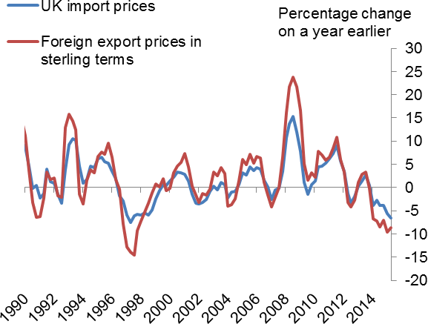A closer look at the data underlying these regressions shows the challenges that these changes in the first stage of pass-through have created for forecasting import prices and inflation in the UK. Figure 9 graphs annual changes in UK import prices and foreign export prices in sterling terms. Through the 1990s and most of the 2000s, UK import prices moved in the same direction as foreign export prices (converted into sterling in Figure 9), but by a smaller amount. Starting around 2010, however, UK import prices began to move

|  |  |
| --- | --- |
| **Figure 9: UK import prices and**  **UK-trade-weighted foreign export prices in sterling terms** | almost one-for-one with foreign export prices. This greater pass-through at this first stage was a key factor discussed by the MPC when explaining why inflation was higher than expected from 2010 through 2013. Over the last year, however, this relationship between UK import prices and foreign export prices seems to have diminished. Movements in foreign export prices have recently been associated with smaller movements in UK import prices than occurred from 2010-2013. If this lower degree of pass-through at the first stage continues, there could be less drag on inflation from sterling’s recent appreciation than models would predict using  the recent past to estimate pass-through. |

To summarize, recent evidence from the UK supports results from several countries at different time periods

– that pass-through appears to change over time. Given that this point has been made in the past, it is unclear why it has not been incorporated in mainstream thinking and analysis on pass-through. This may partly reflect the impossibility of forecasting pass-through if it changes over time – and especially if one does not fully understand why it changes.

# A new approach: consider why the exchange rate moved

Let me summarize what we’ve learned (or not learned) so far. CPI-components with higher import intensities do not seem to be systemically more sensitive to changes in the exchange rate. Sectors which are more tradable and face greater international competition do not seem to be systemically more sensitive to changes in the exchange rate. Changes in the exchange rate do not seem to affect different goods and sectors in the most basic ways which one would expect. And pass-through does not seem to be constant over time – even just the first stage of pass-through from exchange rate movements to import prices. There must be a critical

missing piece. There must be other channels by which changes in the exchange rate can affect different sectors and the CPI and that could explain these three puzzles.

One possibility is that when we discuss how exchange rate movements affect import prices and inflation, we tend to ignore what caused the exchange rate to move in the first place. We simply take the exchange rate fluctuation as given, i.e., as an “exogenous shock”. But very different types of factors or shocks cause exchange rate movements. For example, if sterling appreciated due to an increase in UK productivity, companies would be able to lower their final prices (to match cheaper imports) and still maintain margins and sale volumes. On the other hand, if sterling appreciated due to a sharp increase in UK demand, companies might not lower their final prices due to their expectations for strong domestic sales. Why the exchange rate initially moves could clearly be important in determining how companies respond and adjust prices. This is an issue which has received some attention in the theoretical literature, but almost no attention in the voluminous empirical literature on pass-through. 28 The one notable exception is Shambaugh (2008).

A new research paper (Forbes, Hjortsoe, and Nenova, 2015), however, develops these ideas more formally and tests them empirically. This is a long research paper – so I will only briefly summarize the framework, model, and key results. I hope you will look at the longer paper and send any comments and suggestions.

In this paper, we use an SVAR model to identify six different domestic and global shocks which could impact the exchange rate as well as import prices, consumer prices, GDP, interest rates, and foreign export prices. The six shocks on which we focus are: UK supply shocks, UK demand shocks, UK monetary policy shocks, exogenous exchange rate shocks, global supply shocks, and global demand shocks. These six shocks can incorporate most factors that one would believe could drive exchange rate movements. For example, a UK supply shock could capture changes in UK productivity growth, and a global supply shock could capture changes in oil prices. To identify these shocks we impose a set of identification criteria consistent with economic theory. We use a combination of zero short- and long-run restrictions, combined with sign restrictions.29

We use this framework to estimate a VAR model using quarterly data over the period 1980q2 through 2015q1.30 To simplify comparisons, we look at different scenarios under which sterling would have appreciated by 1% after four quarters. In other words, we set the magnitude of each of the shocks (to UK demand, UK supply, etc.) as needed to cause an identical 1% exchange rate appreciation at the end of 4

28 For example, Corsetti and Dedola (2007) show that the degree of pass-through varies based on whether the shock hits upstream or downstream producers, and Corsetti, Leduc and Dedola (2005) stress the importance of controlling for the general-equilibrium effects of the shocks leading to exchange rate movements when measuring pass-through. Of course, economic forecasts do control for different shocks to demand and supply to some extent.

29 Our identification strategy rests on several key assumptions, all of which are explained in more detail in the paper. First, only supply

shocks affect the level of output in the long run. Second, domestic shocks do not affect world (ex-UK) export prices on impact or in the long run (which is logical for a small open economy such as the UK, albeit not all countries). Finally, we impose several short-term sign restrictions on domestic shocks. Supply shocks are associated with a negative correlation between GDP and the CPI, and demand shocks are associated with a positive correlation between GDP, the CPI and the exchange rate. Expansionary monetary policy shocks are associated with a rise in GDP and the CPI and a depreciation of the exchange rate. Exogenous exchange rate appreciations imply a fall in the CPI and no resultant increase in the interest rate. Importantly, no restrictions are imposed on import prices.

30 The VAR includes two lags of the explanatory variables and is estimated with Bayesian methods, using standard Minnesota priors.

quarters. Then we estimate the accumulated impulse responses to see how the different variables would respond to this 1% appreciation based on what caused the appreciation.

Figure 10 graphs the results for the estimated median effects on the exchange rate (in red), import prices (in green), and consumer prices (in blue) from the six different shocks. It is immediately apparent that the impact of a 1% appreciation on import prices and consumer prices can vary significantly based on what caused the appreciation. And these effects vary not only in their magnitude and duration, but even in their sign.31 There are a number of noteworthy results in these graphs, so it useful to discuss the results for the different phases of pass-through separately.

Figure 11a summarizes the results from Figure 10 for the effect of the six appreciation scenarios on import prices, i.e., the first stage of pass-through. It shows that exchange rate appreciations are associated with lower import prices in all cases, except when the appreciation results from a positive shock to global demand. This makes sense; import prices would normally fall after sterling appreciates. But, if an increase in global demand simultaneously creates inflationary pressure for world prices (and, in turn, for UK import prices), this could outweigh the downward pressure on UK import prices from the appreciation.32 An appreciation that results from a positive shock to UK demand also creates less drag on import prices than the other factors, but since a domestic demand shock has less effect on foreign export prices, UK import prices still fall some.

This minimal effect on UK import prices from UK demand shocks is also intuitive. An improvement in demand would simultaneously drive up UK inflation, making it less necessary for importers to reduce their prices, despite a lost off competitiveness internationally. The strongest negative effect on import prices after four quarters (when this first stage of pass-through is largely complete) is when the appreciation results from a global supply shock.

31 There is obviously significant uncertainty around these impulse responses and Forbes, Hjortsoe and Nenova (2015) discuss this in greater detail.

32 The full set of results also shows that the increase in import prices is lower than the increase in world prices.

# Figure 10: Median impulse responses of the exchange rate, import prices and CPI to appreciations

20

16

12

8

4

0

4

3

2

1

0

-1

-2

-3

-4

Exchange rate Import prices

Consumer prices

0 4 8 12 16 20

4

3

2

1

0

-1

-2

-3

-4

Exchange rate Import prices

Consumer prices

20

16

12

8

4

0

2

1

0

-1

-2

-3

-4

Consumer prices

3

Import prices

4

Exchange rate

0 4 8 12 16 20

4

3

2

1

0

-1

-2

-3

-4

Exchange rate

Import prices

Consumer prices

20

16

12

8

4

0

4

3

2

1

0

-1

-2

-3

-4

Exchange rate

Import prices Consumer prices

20

16

12

8

4

0

-1

-2

-3

-4

Exchange rate

Import prices Consumer prices

4

3

2

1

0

**Supply shock Demand shock**

**Monetary policy shock Exchange rate shock**

**Global supply shock Global demand shock**

Moving to the second stage of pass-through, Figure 11b summarizes the results from Figure 10 on the impact of the six appreciation scenarios on CPI inflation. Appreciations associated with positive UK supply shocks – such as productivity gains – cause the sharpest fall in inflation. Global supply shocks also cause a fall in UK inflation, although by a smaller amount. This is intuitive as supply shocks can reduce prices – in and above their impact on the CPI – and allow companies to keep margins constant while still lowering prices in response to an appreciation. Perhaps most striking, however, are the large positive effects on inflation after an appreciation if this is driven by a positive shock to UK or global demand. Apparently stronger UK or global demand can allow companies to avoid lowering prices after an appreciation. This supports some evidence that income effects – faster growth in exporting countries – can outweigh price effects from exchange rate movements.33

|  |  |
| --- | --- |
| **Figure 11a: Ratio of import price response vs**  **exchange rate response to each shock** | **Figure 11b: Ratio of CPI response vs exchange**  **rate response to each shock** |

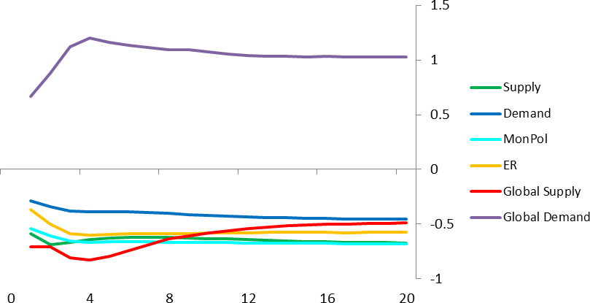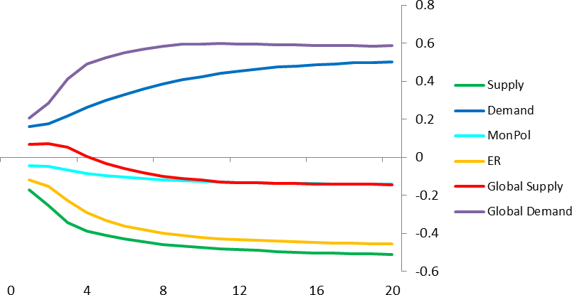

These results on how appreciations can have different effects on import prices and inflation based on what caused the exchange rate to move may be intuitive, but can they explain some of the changes in exchange rate pass-through experienced by the UK over the last few years? To test this, we use this SVAR framework to decompose changes in the sterling exchange rate index since 1981. More specifically, Figure 12 graphs exchange rate changes in black, and then each quarter breaks down how much of any exchange rate movement results from the same six shocks: UK supply shocks, UK demand shocks, UK monetary policy shocks, exogenous exchange rate shocks, global supply shocks, and global demand shocks.34 Changes in UK demand and UK monetary policy (the light and dark blue shading) have been the key drivers behind the large movements in sterling over much of this period. These types of shocks are responsible for the “normal” levels of pass-through.

33 See Forbes (2014).

34 The full paper also performs this decomposition for the other five variables in the paper: import prices, CPI inflation, GDP, interest rates, and foreign export prices.

# Figure 12: Historical shock decomposition of annual changes in sterling exchange rate index

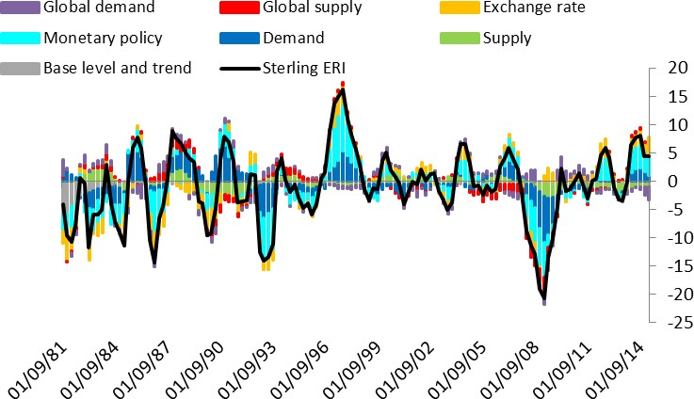

But in order to understand why pass-through has changed over time, it is necessary to examine how the sources of shocks behind major exchange rate movements have changed over time. Since it is difficult to discern these differences in the colourful and detailed graphs since 1981, Figure 13 blows up the parts of the graph related to the two largest recent sterling depreciations (1992 and 2007-8) and two appreciations

(1996-7 and 2013-5).

The 2007-8 depreciation stands out in these graphs for the role of negative global and UK supply shocks (in red and green).35 These sharp negative supply shocks are unusual – even for a depreciation. The discussion above also highlighted that currency movements resulting from negative global, and especially UK, supply shocks tend to be associated with substantially larger price movements than other types of shocks. In other words, the nature of the shocks causing the 2007-8 depreciation could have caused the higher rate of

pass-through than expected, and the corresponding higher rate of inflation than forecast. And although the above discussion focused on the channels through which this would occur during an appreciation, they also apply after a depreciation. More specifically, if a depreciation occurred partly due to a sharp negative UK or global supply shock (reflecting lower productivity and/or a collapse in the financial system that increased financial constraints), then UK firms might take advantage of higher import prices to raise domestic prices in order to pay for higher production costs and generate enough cash flow to stay in business. Gilchrist and Zakrajsek (2015) present strong evidence that these types of effects were important in explaining why inflation did not fall as much during the crisis as would have been expected by the contraction in demand.

35 Both these negative global shocks depreciate the exchange rate because even though they are global (affecting the world and UK simultaneously), they might impact the UK relatively more than the rest of world, such that the exchange rate depreciates.

# Figure 13: Historical shock decomposition of four large moves in the exchange rate (cumulative percent change since preceding peak/ trough)

|  |  |
| --- | --- |
| **1992 depreciation** | **1996/7 appreciation** |
| **2007/8 depreciation** | **2013/4/5 appreciation** |

In contrast to the depreciation episode after the crisis, global and UK supply shocks have not played an important role in driving sterling’s most recent appreciation. If anything, weakness in UK supply (undoubtedly reflecting weak productivity growth) has moderated the appreciation. As a result, UK companies are likely finding it more difficult to reduce their prices to compete with cheaper imports than they would if ways had been found to raise productivity. This could be why a key reason why there appears to be less pass-through from recent exchange rate movements today than occurred during the 2007/8 depreciation.

# Conclusions and implications for monetary policy

In Shakespeare’s play “Much Ado about Nothing”, the word “nothing” was not only a reference to the tremendous fuss made about events which should have had no import, but also a play on the terms “noting” or “noticing” (which were pronounced as “nothing” in old English). In other words, the play was also a lesson on the importance of paying attention to details and truly understanding what is going on. If the key

characters in the play had been more careful to verify what they thought they knew before jumping to assumptions, they could have avoided much heartache and drama.

As this talk has shown, this insight on the importance of “noting” is also critically important when analysing how exchange rate movements affect inflation – and therefore monetary policy. Some of our most basic assumptions and priors do not do a particularly good job in explaining recent pass-through in the UK. More specifically, sectors with a higher imported content do not systemically appear to be more sensitive to sterling’s movements. Sectors that are more tradable and face greater international competition show only limited evidence of greater sensitivity to sterling’s moves. And the extent of pass-through from sterling’s movements to both CPI inflation as well as import prices has changed over time. This has created substantial challenges to predicting how recent exchange rate movements will affect inflation in the future.

After “noting” these challenges, it is clear that we need to rethink how we assess the impact of exchange rate movements on prices. My comments propose a new approach that puts more emphasis on the underlying reasons why the exchange rate moves. This can help explain some of the puzzles in pass-through and why exchange rates can have different effects on import prices and inflation at different times. This approach can also help explain the sharp increase in pass-through and surprising pickup in inflation after the crisis.

Perhaps most important for monetary policy today, this approach also suggests that sterling’s recent appreciation could create less drag on import prices and inflation than we might have expected if the levels of pass-through seen after the crisis persisted. If this plays out, monetary policy would need to be tightened sooner than based on the older models. Some may not view this as the happy ending in Shakespeare’s play when the star-crossed lovers were finally reconciled. But a better understanding of pass-through would improve our ability to forecast inflation and adjust monetary policy in advance as appropriate, avoiding the types of errors that lead to drama and heartache.

**References**

Bussiere, Matthieu, Lopez, Claude and Tille, Cedric (2015). “Currency Crises in Reverse: Do Large Real Exchange Rate Appreciations Matter for Growth?”, *Economic Policy* 30(81).

Corsetti, Giancarlo, Dedola, Luca and Leduc, Sylvain, 2007. "Optimal Monetary Policy and the Sources of Local-Currency Price Stability", *International Dimensions of Monetary Policy, National Bureau of Economic Research, Inc., pages 319-367*

Corsetti, Giancarlo, Dedola, Luca and Leduc, Sylvain, 2005. "DSGE Models of High Exchange-Rate Volatility and Low Pass-Through," *CEPR Discussion Papers 5377*

Fisher, Stanley (2015). “US inflation developments”, Speech given at the Federal Reserve Bank of Kansas City Economic Symposium, Jackson Hole on August 29, 2015.

Fleer, Rita, Rudolf, Barbara and Zurlinden, Mathias (2015). “Price change dispersion and time-varying pass-through into consumer prices”, mimeo.

Forbes, Kristin (2015a). “[Risks around the Forecast](http://www.bankofengland.co.uk/publications/Documents/speeches/2015/speech793.pdf)”, Speech given in London on January 22, 2015.

Forbes, Kristin (2015b). “[When, why, and what’s next for low inflation?: No magic slippers needed](http://www.bankofengland.co.uk/publications/Documents/speeches/2015/speech823.pdf)”,Speech given at the London School of Economics on June 17, 2015.

Forbes, Kristin (2014). “[The economic impact of sterling’s recent moves: more than a midsummer night’s](http://www.bankofengland.co.uk/publications/Documents/speeches/2014/speech760.pdf) [dream](http://www.bankofengland.co.uk/publications/Documents/speeches/2014/speech760.pdf)”, Speech given in London on October 1, 2014.

Forbes, Kristin, Hjortsoe, Ida and Nenova, Tsvetelina. (2015). “The Shocks Matter: New Evidence on Exchange Rate Pass-Through.” Forthcoming.

Gilchrist, Simon and Zakrajsek, Egon. (2015). “Customer Markets and Financial Frictions: Implications for Inflation Dynamics”. Federal Reserve Bank of Kansas City Economic Symposium, Jackson Hole.

Gopinath, Gita (2015). “The International Price System”, Federal Reserve Bank of Kansas City Economic Symposium, Jackson Hole.

Kirby, Simon and Meaning, Jack, 2014. “Exchange rate pass-through: a view from a global structural model”,

*National Institute Economic Review No. 230 November 2014*.

Marazzi, Mario, Sheets, Nathan, Vigfusson, Robert J., Faust, Jon, Gagnon, Joseph , Marquez, Jaime, Martin, Robert F., Reeve, Trevor and Rogers, John, 2005. "[Exchange rate pass-through to U.S. import](https://ideas.repec.org/p/fip/fedgif/833.html) [prices: some new evidence](https://ideas.repec.org/p/fip/fedgif/833.html)," [International Finance Discussion Papers](https://ideas.repec.org/s/fip/fedgif.html) 833, Board of Governors of the Federal Reserve System (U.S.).

Mumtaz, Haroon, Oomen, Ozlem and Wang, Jian, 2006. “Exchange rate pass-through into UK import prices”, Bank of England Working Paper No. 312.

Shambaugh, Jay (2008). “A new look at pass-through”, *Journal of International Money and Finance, No. 27*, pp 560-591.

Stulz, Jonas (2007). “Exchange rate pass-through in Switzerland: Evidence from vector autoregressions”,

*Swiss National Bank Economic Studies, No. 4*.

Appendix A: Tables with the 10 CPI components most correlated with movements in the sterling exchange rate, oil prices, foreign export prices excluding fuel and the UK output gap

|  |  |  |
| --- | --- | --- |
| **Top-10 sensitive to sterling:** | **Coefficient** | **ONS import intensity** |
| Passenger Transport by Air | -1.29 | 0.00 |
| Vegetables Including Potatoes and Other Tubers | -1.22 | 0.38 |
| Gas | -0.71 | 0.00 |
| Fuels & Lubricants | -0.54 | 0.21 |
| Books | -0.35 | 0.14 |
| Other Personal Effects | -0.20 | 0.34 |
| Tobacco | -0.19 | 0.10 |
| Other Medical and Therapeutic Equipment | -0.16 | 0.39 |
| Products for the Regular Repair of Dwelling | -0.12 | 0.27 |
| Food Products | -0.06 | 0.31 |

|  |  |  |
| --- | --- | --- |
| **Top-10 sensitive to oil prices:** | **Coefficient** | **ONS import intensity** |
| Liquid Fuels | 0.53 | 0.20 |
| Fuels & Lubricants | 0.18 | 0.21 |
| Financial Services N.E.C. | 0.08 | 0.00 |
| Insurance Connected With the Dwelling | 0.04 | 0.00 |
| Sewerage Collection | 0.02 | 0.00 |
| Water Supply | 0.02 | 0.00 |
| Other Articles of Clothing & Accessories | 0.01 | 0.31 |
| Social Protection | 0.01 | 0.02 |
| Jewellery Clocks and Watches | 0.01 | 0.33 |
| Actual Rents for Housing | 0.01 | 0.00 |

|  |  |  |
| --- | --- | --- |
| **Top-10 sensitive to foreign export prices:** | **Coefficient** | **ONS import intensity** |
| Gas | 4.27 | 0.00 |
| Passenger Transport by Sea and Inland Waterway | 2.64 | 0.00 |
| Passenger Transport by Air | 1.99 | 0.00 |
| Garden Plants and Flowers | 0.78 | 0.29 |
| Carpets & Other Floor Coverings | 0.69 | 0.18 |
| Equipment for Sport Camping and Open-Air Recreation | 0.68 | 0.35 |
| Tools and Equipment for House and Garden | 0.67 | 0.31 |
| Products for the Regular Repair of Dwelling | 0.64 | 0.27 |
| Other Personal Effects | 0.52 | 0.34 |
| Coffee, Tea, Cocoa | 0.48 | 0.28 |

|  |  |  |
| --- | --- | --- |
| **Top-10 sensitive to UK output gap:** | **Coefficient** | **ONS import intensity** |
| Gas | 0.02 | 0.00 |
| Fuels & Lubricants | 0.01 | 0.21 |
| Insurance Connected With the Dwelling | 0.01 | 0.00 |
| Non-Durable Household Goods | 0.01 | 0.26 |
| Postal Services | 0.01 | 0.01 |
| Photographic, Cinematographic & Optical Equipment | 0.01 | 0.39 |
| Garments | 0.00 | 0.42 |
| Repair of Audio-Visual,Photo. & Data Processing Equip | 0.00 | 0.00 |
| Food Products | 0.00 | 0.31 |
| Dry-Cleaning, Repair and Hire of Clothing | 0.00 | 0.01 |

Appendix B**:**

To construct the first measure, we conjecture that goods that are tradable must have relatively *similar average price levels across countries*, i.e. they must satisfy the law of one price on average. We measure tradability for each good as its average deviation from the LOOP over the period 1997-2014 (compared to the average deviation from the LOOP of all goods to correct for any deviations affecting all goods e.g. VAT differences or local costs). Formally, this measure of tradability in industry *i* is

( )

[ ] .

A concern with this measure, however, is that it does not penalise large deviations from the LOOP if these are subsequently offset by equally large deviations from the LOOP in the opposite direction. We therefore also consider a second measure of tradability which considers the dynamics of relative prices.

This second statistics measures the extent to which each sector has experienced deviations from the law of one price over the time period considered. In particular, we construct a measure of the variance of each good’s LOOP deviation from the average LOOP deviation over 1997-2004. That is,

( )

( ).